Looking Good: The Psychology and Biology of Beauty
In ancient Greece, Helen of Troy was the paragon of beauty, showing a physical brilliance that would put Cindy Crawford to shame. Indeed, she was the toast of Athens, celebrated not for her kindness or her intellect, but for her physical perfection. But why did the Greek men find Helen, and other beautiful women, so intoxicating?
In an attempt to answer this question, the philosophers of the day devoted a great deal of time to this enigma. Plato wrote of so-called "golden proportions," in which, amongst other things, the width of an ideal face would be two-thirds its length, while a nose would be no longer than the distance between the eyes.
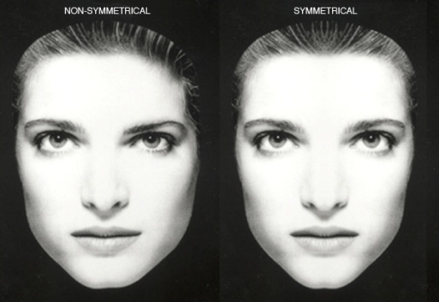
Today, this symmetry has been scientifically proven to be naturally attractive to the human eye. It has been defined not with proportions, but rather with similarity between the left and right sides of the face. Thus, the Greeks were only partially correct.
Babies spend more time staring at pictures of symmetric individuals than they do at photos of asymmetric ones. Victor Johnston of New Mexico State University, for example, uses a program called FacePrints, which shows viewers facial images of variable attractiveness. The viewers then rate the pictures on a beauty scale from one to nine. The pictures with the best ratings are merged together, while the less attractive photos are weeded out. Each trial ends when a viewer gives the composite a 10. All the perfect 10s are super-symmetric.
Scientists say that the preference for symmetry is a highly evolved trait seen in many different animals. Female swallows, for example, prefer males with longer and more symmetric tails, while female zebras mate with males with symmetrically colored leg bands.
The rationale behind symmetry preference in both humans and animals is that symmetric individuals have a higher mate-value; scientists believe that this symmetry is equated with a strong immune system. Thus, beauty is indicative of more robust genes, improving the likelihood that an individual's offspring will survive. This evolutionary theory is supported by research showing that standards of attractiveness are similar across cultures. According to a University of Louisville study, when shown pictures of different individuals, Asians, Latinos, and whites from 13 different countries all had the same general preferences when rating others as attractive - that is those that are the most symmetric.
The halo effect. In society, attractive people tend to be more intelligent, better adjusted, and more popular. This is described as the halo effect - due to the perfection associated with angels. Research shows attractive people also have more occupational success and more dating experience than unattractive ones.
An alternative explanation for attractive people achieving more in life is that we automatically categorize others before having an opportunity to evaluate their personalities, based on cultural stereotypes which say attractive people must be intrinsically good, and ugly people must be inherently bad.
For better or worse, the bottom line is that research shows beauty matters; it pervades society and affects how we choose loved ones. Thus, striving to appear attractive may not be such a vain endeavor after all. This isn't to say plastic surgery is necessarily the answer. Instead, lead a healthy lifestyle that will in turn make you a happier person.

Are the following statements TRUE or FALSE?
1. Greeks celebrated the kindness and intellect of Helen of Troy.
2. According to Plato your face is perfect if it is two thirds of its length.
3. Nowadays people are not attracted to symmetric face.
4. Babies spend a lot of time staring at pictures of themselves.
5. Animals also look for perfect mate.
6. Scientists believe that symmetry is equated with a strong immune system.
7. The halo effect is associated with the perfection of angels.
8. The intelligence of people is connected with their beauty.
9. We automatically categorize others before evaluation of their personality.

