STAR SAYS SHE DOESN'T HAVE TO DIE YOUNG IN ORDER TO BE A 'LEGEND'...
08:53, Friday, 15 November 2013

Lady Gaga has vowed not to become a member of the tragic 27 Club after curbing her addiction to cannabis.
Earlier this month, Mother Monster confessed to developing a heavy marijuana habit, telling Attitude magazine that after breaking her hip, she smoked up to 15 joints a day.
According to The Sun, Gaga is 'terrified' of going down the same path as Amy Winehouse, Kurt Cobain and Jimi Hendrix - who all passed away at the age of 27.

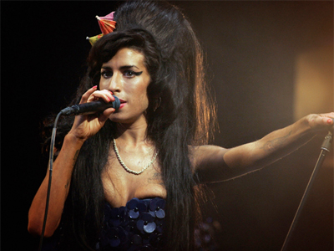
In comments taken from a recent interview with Carson Daly for his 97.1 AMP Radio Show, the tabloid quotes Lady G as saying: "I want to live and I want my fans to live. I don’t want them to torture themselves in the way I have.
“I want to show people that I will last past 27 and I will last longer, and so will you.”
Gaga - who turns 28 in March 2014 - went on to add she hopes to break the curse of the 27 Club, explaining: "I want to change this code in the atmosphere that in order to be remembered I must die young…
"That in order to be remembered as a legend, I must be dead first. This is unhealthy.”
Referencing her previous drug habit, the Bad Romance hitmaker concluded: "Can I be brilliant without it? I know that I can be and I have to be, because I want to live.”
(MTV UK, 2013)
Translate the words which are written in bold type.

Translate the title of the article into your own language.

Summarize the article in +/- 40 words. What is the article about?

Do this exercise after you have listened to the song on the next page. What do you think is the connection between the song and the article?

Lady Gaga - Dope

Put the lines in the correct order [1 – 13].

[ ] The party's just begun
[ ] Cork's off, it's on
[ ] Drink is my last one
[ ] I promise this
[ ] Oh I will hate myself until I die
[ ] God forgive my sins
[ ] I know I fucked up again
[ ] Don't leave me, I
[ ] Because I lost my only friend

Listen to the song and write down the correct word.

My _______ would break without you
Might not awake _______ you
Been hurting low, from living _______ for so long
I'm sorry, and I love you
_______ with me, "Bell Bottom Blue"
I'll keep on searching for an _______ cause I need you more than dope
I need you more than _______
Need you more than dope
Need you more than dope
I need you more than dope

Choose (circle) the correct word.

Toast one last stuff / puff
And two / too last regrets
tree / three spirits and
Twelve lonely steps / stops
Up heaven's stairway to gold / cold
Mine myself like coal / goal
A mountain of a sole / soul
Each day, I cry
Oh, I feel so low from living high / hay
___________________________________________________________________
Write down 5 irregular verbs from the lyrics. Write down all three forms.

Infinitive | Past simple | Past participle
Go to www.lyricstraining.com and practise some more songs! Choose the ones you like. It doesn’t have to be a Lady Gaga song ;)

