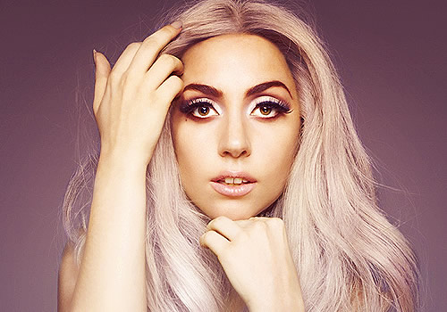
Stefani Joanne Angelina Germanotta (born March 28, 1986), who performs under the stage name Lady Gaga, is a singer, songwriter and musician from New York City, New York, United States.

Despite her affluent upbringing on Manhattan's Upper West Side, Gaga says that her parents "both came from lower-class families, so we've worked for everything—my mother worked eight to eight out of the house, in telecommunications, and so did my father." She studied at private catholic school and briefly attended New York University's Tisch School of the Arts. She described her academic life in high school as "very dedicated, very studious, very disciplined" but also "a bit insecure".

Gaga left school at 19, in the second semester of her sophomore year, deciding to focus on her musical career. Her father agreed to pay her rent for a year, on the condition that she re-enroll at Tisch if she won’t achieve success. "I left my entire family, got the cheapest apartment I could find, and ate shit until somebody would listen," she remembers.
In 2006 she recorded her first two songs as Lady Gaga (Fever and Wonderful) on Def Jam records, but was later let go. Devastated, Gaga returned to the family home for Christmas and the nightlife culture of the Lower East Side. She became increasingly experimental: fascinating herself with emerging neo-burlesque shows, go-go dancing at bars dressed in little more than a bikini in addition to experimenting with drugs.
She began her music career as a songwriter for some of pop music’s biggest stars, including Fergie, Pussycat Dolls, Britney Spears and New Kids On The Block, as well as American singer and producer Akon. After Akon recognized that Gaga also had vocal talent, he signed her to a joint deal with his own label, Kon Live Distribution, and then she started to work on her own new material for her debut album.
Gaga released the album “The Fame” in 2008, which she explained was “about how anyone can feel famous.” The Fame then went Diamond in February 2010, Selling over 12 million copies worldwide. The single "Applause" was released on August 12, 2013 and the new album is scheduled to be released on November 11, 2013.

Curious facts

- Lady Gaga calls her fans “Monsters”
- This is how she wrote “Edge of Glory” song: My grandpa died about five months ago, and my dad and I were going to say goodbye to him at the hospice, and I got out a big thing of agave tequila and my dad sat next to me at the piano and we started to doing shots back and forth, and I wrote 'Edge of Glory' on the piano and my dad and I cried...
- She has nicknames: Gagaloo, Loopy, Mother Monster, Rabbit Teeth, The Germ, Stefi, Little Mermaid
- She’s left-handed
- She has fourteen tattoos
- Lady Gaga has more facebook fans than President Obama. Currently, Lady Gaga has 17.5 million fans and President Obama has 13.4 million.
- She learned to play piano when she was only 4 years old
- She likes to cook and her favourite food is Italian pasta

