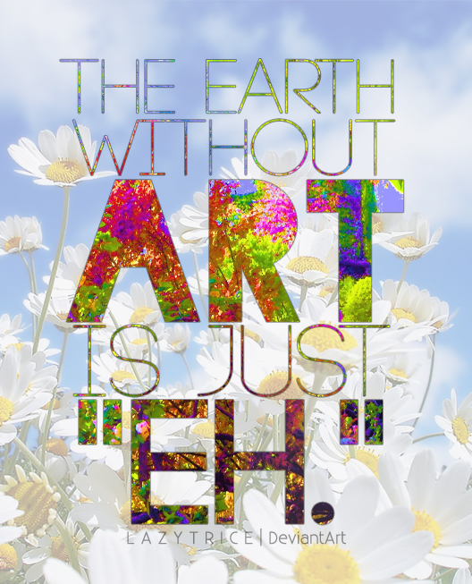

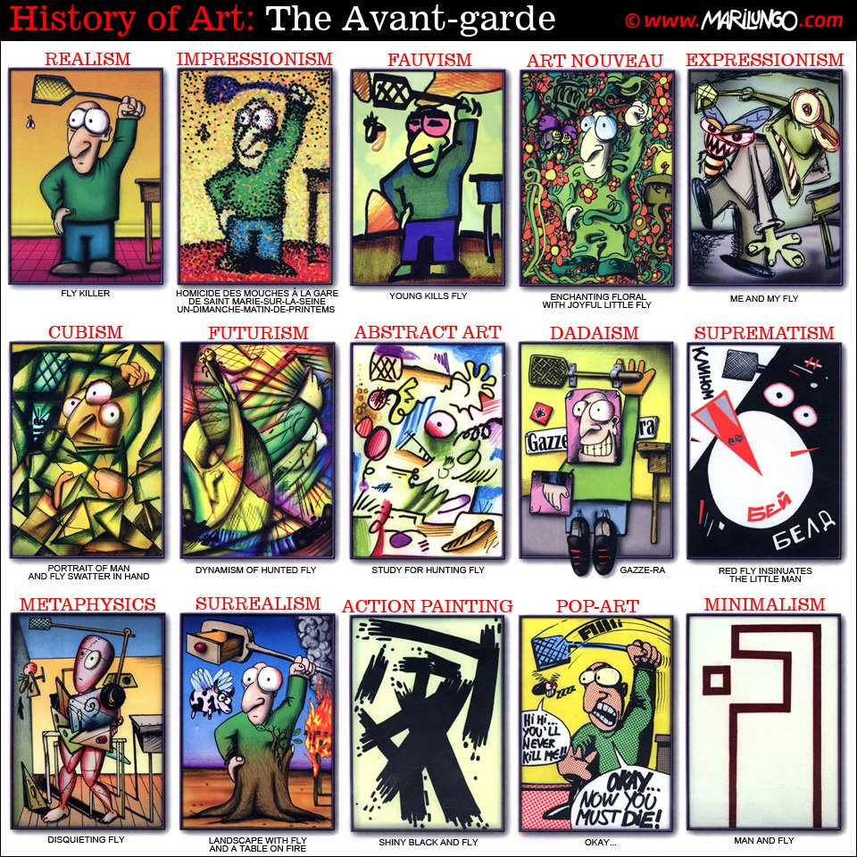

THE HISTORY OF ART
Realism in the arts may be generally defined as the attempt to represent subject matter truthfully, without artificiality and avoiding implausible, exotic and supernatural elements.
Impressionism is characterized by relatively small, thin, yet visible brush strokes, emphasis on accurate depiction of light in its changing qualities, ordinary subject matter.
Fauvism breaks with Impressionism as well as with older, traditional methods of perception. It introduces bold and vivid brushstrokes and vibrant nonnaturalistic colors directly from the tube.
Art Nouveau (New Art) is a style of decoration and architecture of the late 19th and early 20th centuries, characterized particularly by the depiction of leaves and flowers in flowing, sinuous lines.
Expressionism is an artistic style in which the artist seeks to depict not objective reality but rather the subjective emotions. The artist accomplishes this aim through distortion, exaggeration and fantasy and through the vivid, irritating or dynamic depiction of elements.
Cubist painters rejected the concept that art should copy nature, so they reduced and distorted objects into geometric forms.
Futurism is an artistic movement that violently rejected traditional forms so as to include into the art the energy and dynamism of modern technology.
Abstract Art that does not depict a person, a place or a thing in the natural world - even in an extremely distorted or exaggerated way. Therefore, the subject of the work is based on what you see: color, shapes, brushstrokes etc.
Dadaism is an artistic movement that that rejected conventional aesthetic and cultural values by producing works marked by nonsense, cartoon (caricature) and absurdity.
Suprematism was an art movement, focused on basic geometric forms, such as circles, squares, lines, and rectangles, painted in a limited range of colors. It was founded by Kazimir Malevich in Russia, around 1913.
Metaphysics is the movement began with Chirico, whose dreamlike works with sharp contrasts of light and shadow often had a threatening, mysterious quality, he was 'painting that which cannot be seen'.
Surrealistic artists painted illogical scenes with photographic precision, created strange creatures from everyday objects and expressed their imagination as revealed in dreams, free of the conscious control.
Action painting is a style of painting in which paint is spontaneously dribbled, splashed or smeared onto the canvas, rather than being carefully applied.
Pop-Art includes images from popular culture such as advertising, news, etc. In pop art, material is sometimes visually removed from its known context, isolated, and/or combined with unrelated material. It is aimed to depict images of popular as opposed to find culture in art.
Minimalism is any design or style wherein the simplest and fewest elements are used to create the maximum effect.
THE HISTORY OF ART
_________________ in the arts may be generally defined as the attempt to represent subject matter truthfully, without artificiality and avoiding implausible, exotic and supernatural elements.
_________________ is characterized by relatively small, thin, yet visible brush strokes, emphasis on accurate depiction of light in its changing qualities, ordinary subject matter.
__________________ breaks with Impressionism as well as with older, traditional methods of perception. It introduces bold and vivid brushstrokes and vibrant nonnaturalistic colors directly from the tube.
_________________ is a style of decoration and architecture of the late 19th and early 20th centuries, characterized particularly by the depiction of leaves and flowers in flowing, sinuous lines.
_________________ is an artistic style in which the artist seeks to depict not objective reality but rather the subjective emotions. The artist accomplishes this aim through distortion, exaggeration and fantasy and through the vivid, irritating or dynamic depiction of elements.
_________________ painters rejected the concept that art should copy nature, so they reduced and distorted objects into geometric forms.
_________________ is an artistic movement that violently rejected traditional forms so as to include into the art the energy and dynamism of modern technology.
_________________ that does not depict a person, a place or a thing in the natural world - even in an extremely distorted or exaggerated way. Therefore, the subject of the work is based on what you see: color, shapes, brushstrokes etc.
_________________ is an artistic movement that that rejected conventional aesthetic and cultural values by producing works marked by nonsense, cartoon (caricature) and absurdity.
_________________ was an art movement, focused on basic geometric forms, such as circles, squares, lines, and rectangles, painted in a limited range of colors. It was founded by Kazimir Malevich in Russia, around 1913.
_____________ is the movement began with Chirico, whose dreamlike works with sharp contrasts of light and shadow often had a threatening, mysterious quality, he was 'painting that which cannot be seen'.
____________ artists painted illogical scenes with photographic precision, created strange creatures from everyday objects and expressed their imagination as revealed in dreams, free of the conscious control.
_________________ is a style of painting in which paint is spontaneously dribbled, splashed or smeared onto the canvas, rather than being carefully applied.
_________________ includes images from popular culture such as advertising, news, etc. In pop art, material is sometimes visually removed from its known context, isolated, and/or combined with unrelated material. It is aimed to depict images of popular as opposed to find culture in art.
_________________ is any design or style wherein the simplest and fewest elements are used to create the maximum effect.

